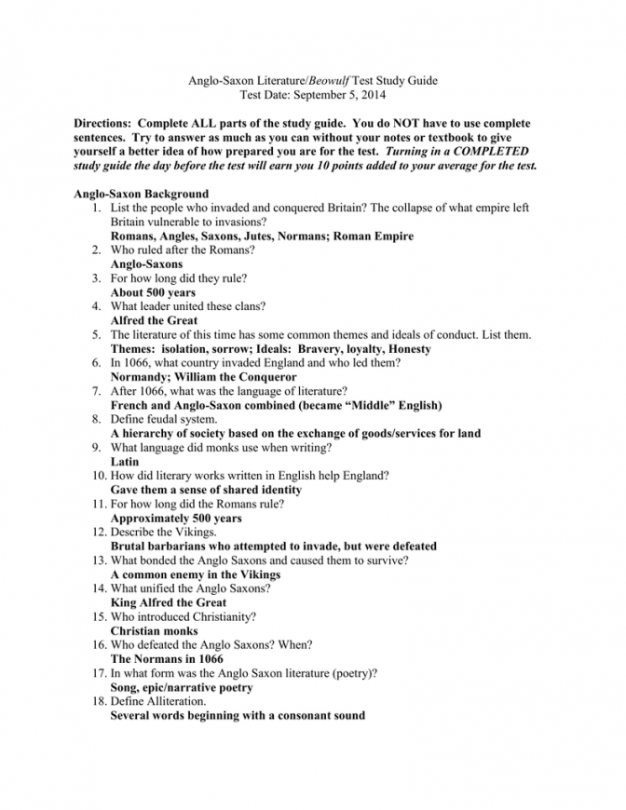
Source: http://mspartners.co/beowulf-characters-movie-worksheet.html

